**Irevolution exploration of apples iphone impact in India**

**1.Introduction :**

The world has changed as a consequence of the increasing use of smartphones, which have improved

Communication, connected people, and revolutionized many different businesses. With its main product, the iPhone, capturing markets around the world, Apple Inc. Has emerged as a prominent player among the top smartphone makers. India, one of the economies with the greatest economic growth, has seen a tremendous increase in smartphone usage, making it an interesting market to study the effects of Apple’s iPhone.

* 1. **Overview :**

1. The iPhone is a smartphone made by Apple that combines a computer, iPod, digital camera, and cellular phone into one device with a touchscreen interface.
2. The iPhone runs the iOS operating system.
3. iPhones Retain Their Performance for a Longer Time.
4. The iPhones have a series of processors that reportedly deliver better performance than most Android phones.
   1. **Purpose:**

The iPhone is a smartphone made by Apple that combines a computer, iPod, digital camera and cellular phone into one device with a touchscreen interface.

1. **Problem Definition & Design Thinking**

Benefits of Design Thinking✨

Since design thinking is an empathy-driven process as opposed to problem identification, it is thought of as a solution-driven approach. This has made it a favourite among most business leaders. Let us take a look at the importance of design thinking.

Helps in effectively meeting client requirements✨

Since prototyping is a part of design thinking, it goes through several rounds of testing and feedback. This means there is assured quality, and the customer is likely to be satisfied with the results.

Helps in tackling creative challenges✨

Here, we are looking at problems through a fresh perspective. Looking at the problem at hand differently and brainstorming various solutions allows the company to use a creative approach. Through design thinking, we can gain feedback from the clients and create a valuable product or service.

Expands your knowledge✨

The entire process goes through multiple stages and does not stop when the deliverables are met. By doing so, you can gain feedback and improve your understanding of the clients. You will gain knowledge about which tools to use, how to close gaps, and more.

**2.1Empathy Map**

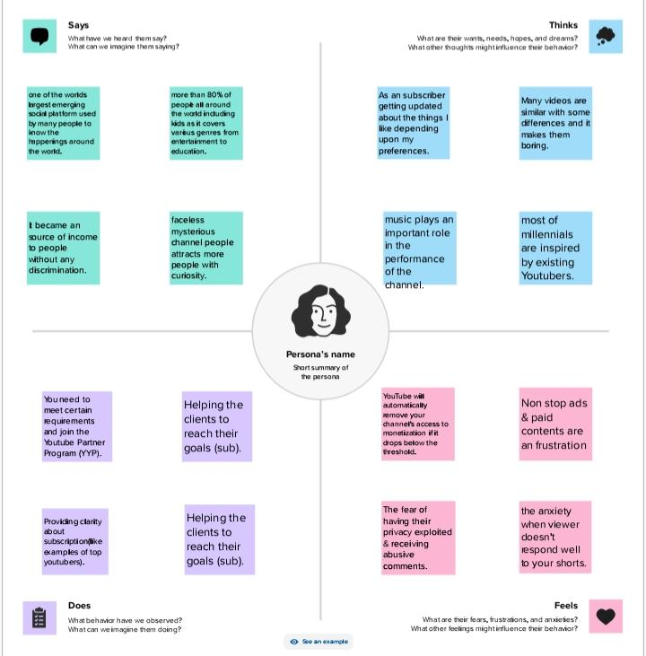

* 1. **Ideation & Brainstorming Map**

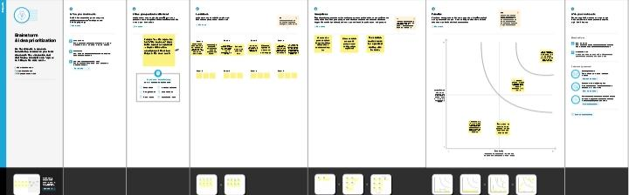

1. **Result**

On average, iPhone users earn more than Android users. People with iPhones tend to spend more on technologies, beauty products, and clothing. Apple dominates the premium smartphone market.

**4. ADVANTAGES & DISADVANTAGES**

**Advantages**

1. User-friendly interface

2. High-quality display

3. Advanced camera

4. Apps ecosystem

5. Seamless integration with other apple devices

**Disadvantages**

1. Cost

2. Non-removable battery

3. Limited customization

4. No Expandable storage

5. Frailty

**5. APPLICATIONS**

**Application on an iPhone**

A software application that runs under iOS, which is the operating system that powers Apple’s mobile devices. In most cases, any application that runs on an iPhone also runs on an iPad and iPod touch. However, apps designed strictly for iPads, which have larger screens, do not work on iPhones and iPods.

**6. CONCLUSION:**

Apple and the iPhone is a great example of a corporation making what the consumer wants in a global market. With limited companies competing, competition for the best phone on the market is at an all-time high.

7. **FUTURE SCOPE**

**Future of iOS Developers**

Nowadays, more and more businesses are adopting the mobile-first approach. Thus, there is a high demand for iOS developers who can build apps for Apple devices. The talent shortage for iOS developers further leads to many developer job opportunities with lucrative salaries

**8. REQUIREMENTS**

To provide support for iPhone X on Quantum Visualizer,

1. Provide a 3X splash image

2. Provide a 2×1 splash video.

3. Add NSFaceIDUsageDescription in the infoplist_configuration.json